Name (in Korean if possible): 이경민
Student ID (8-digits): 22100487
What tracks did you choose? Please check all tracks you chose.
- Genius Track ( )
- Transparency Track ( v )
- Consistency Track ( v )

- (Bonus 1 point) Is the average-case running time of insertion sort linear, quadratic, or of some other order? Prove your answer completely.
Quadratic.
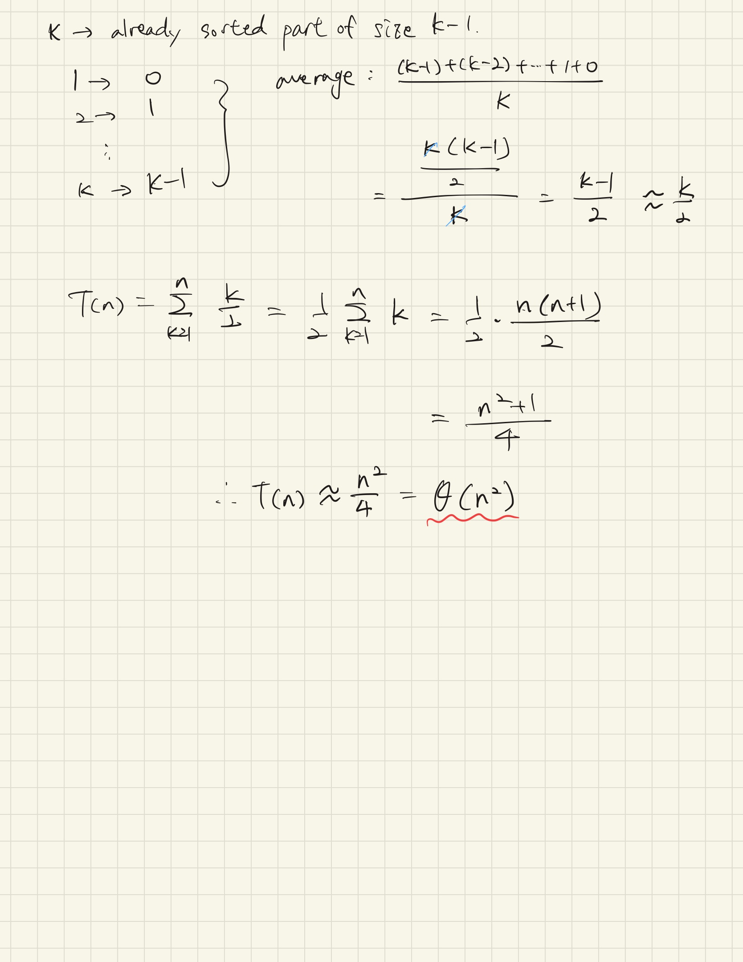
Transparency
    - I asked ChatGPT that what is the meaning of the average-case running time?
    - https://chatgpt.com/share/69b7a108-564c-8012-a673-de7b2c84bf5d

- (2 points) Find the simplest form of $Θ\left(10^{10}n^{2}+10^{5}n+10^{9}\right)$.
$$Θ\left(n^{2}\right)$$
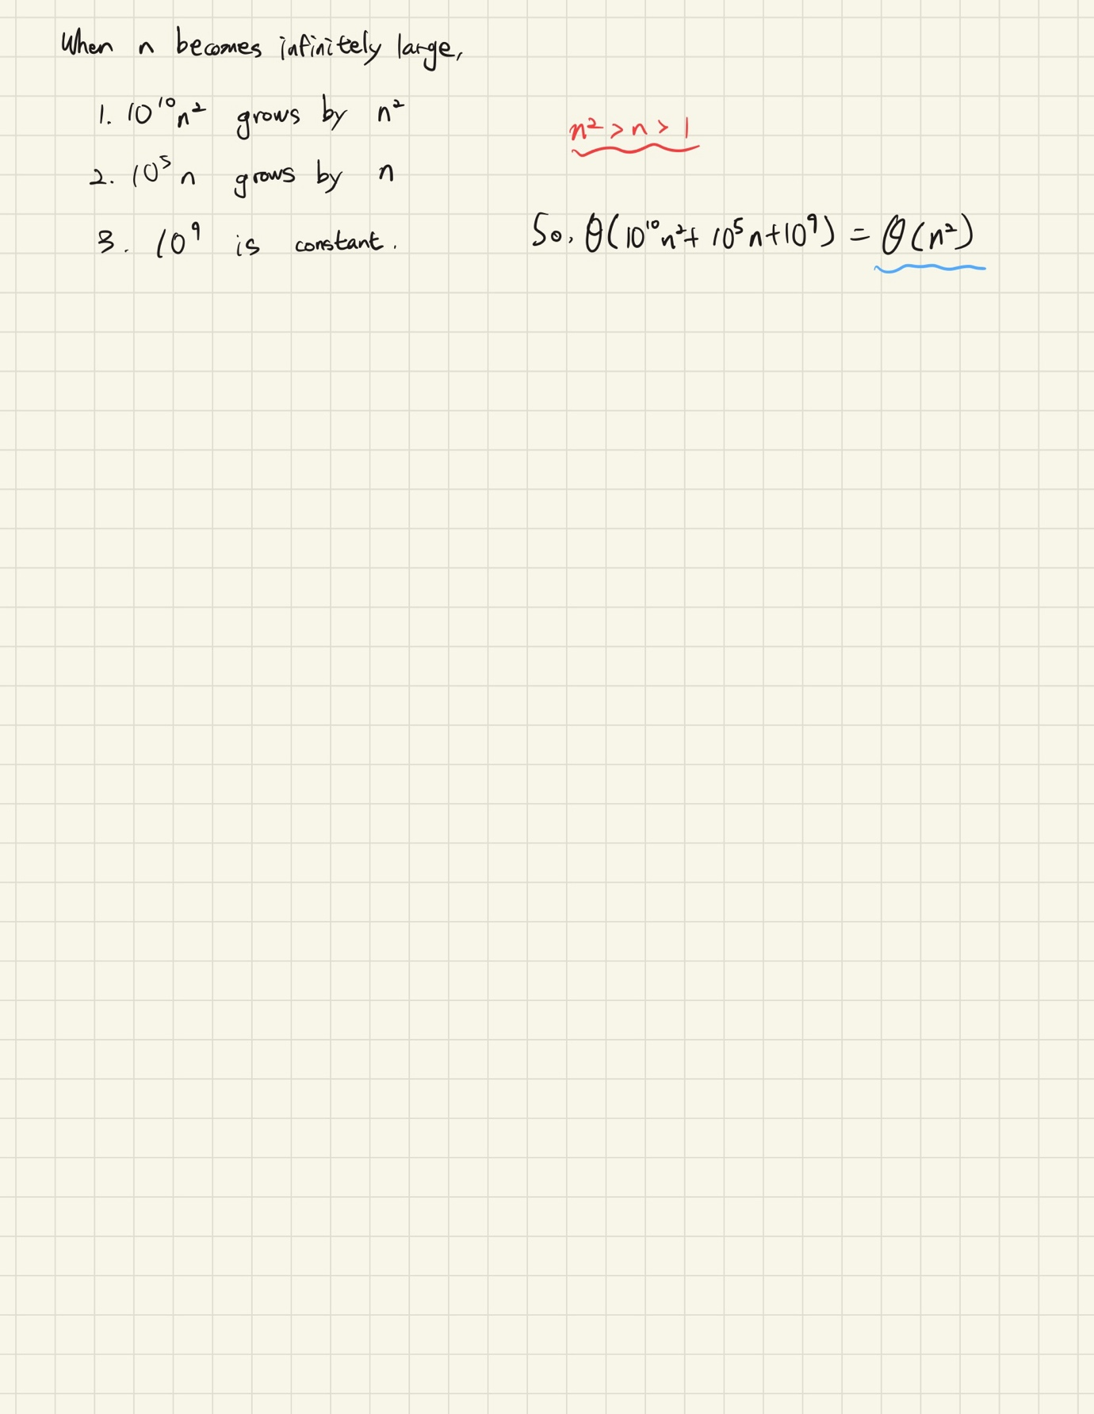
Transparency
    - I used AI. I already know about the answer. But I didn’t know the exact process of how the answer came out. So I asked the reason why the simplest form becomes the highest growth term.
    - https://chatgpt.com/c/69b59b1a-1a20-8324-ac01-9484f19ac85f

- (4 points) Watch the video “Growth Rates of Functions and L'Hospital's Rule” (https://youtu.be/6IjVGfbhe9w) and answer the following question.
Where does $O(n^{\frac{1}{100}})$ belong? Prove your answer completely.
$$Ο\left(1\right)⊂\text{①}⊂Ο\left(lg n\right)⊂\text{②}⊂Ο\left(\sqrt{n}\right)⊂\text{③}⊂Ο\left(n\right)⊂\text{④}⊂Ο\left(n\log{n}\right)$$
$$\text{②}$$

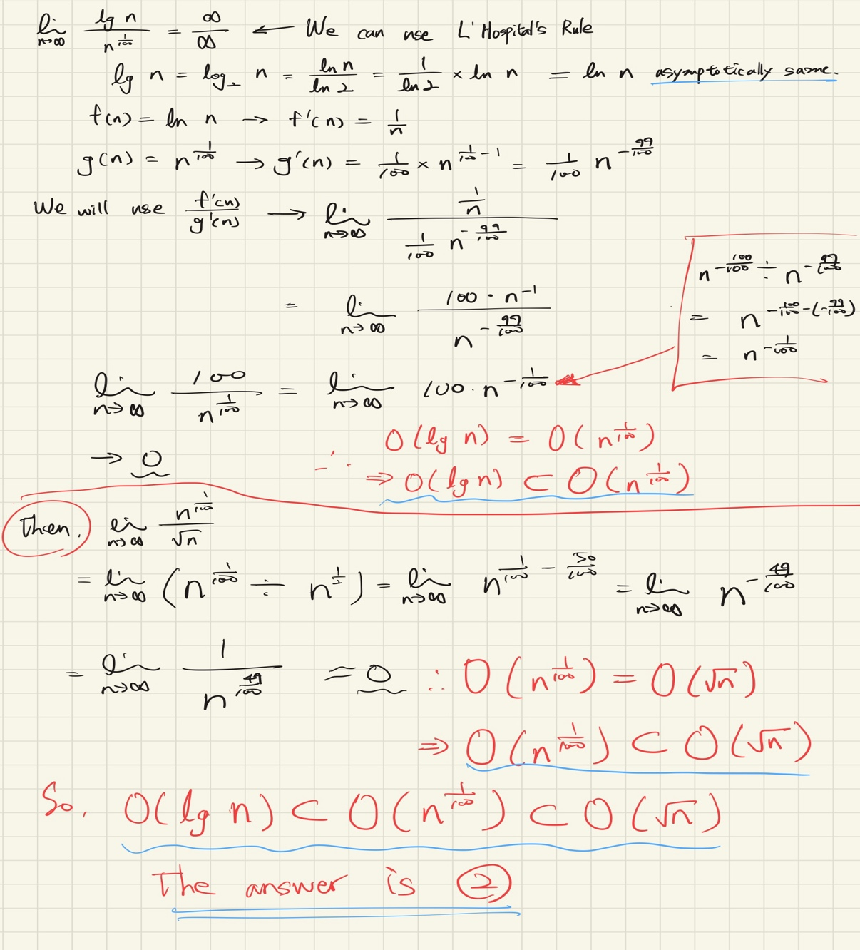
Transparency
    - I used AI to reconfirm the concept of L'Hôpital's Rule and study how to differentiate logarithms.
    - https://chatgpt.com/share/69b7af40-28f4-8012-ab57-703f5eb0c68b

- (Bonus 1 point) Which one is correct? Prove your answer completely.
$Ο\left(n2^{n}\right)⊂Ο\left(n!\right)$ or $Ο\left(n!\right)⊂Ο\left(n2^{n}\right)$
$$Ο\left(n2^{n}\right)⊂Ο\left(n!\right)$$
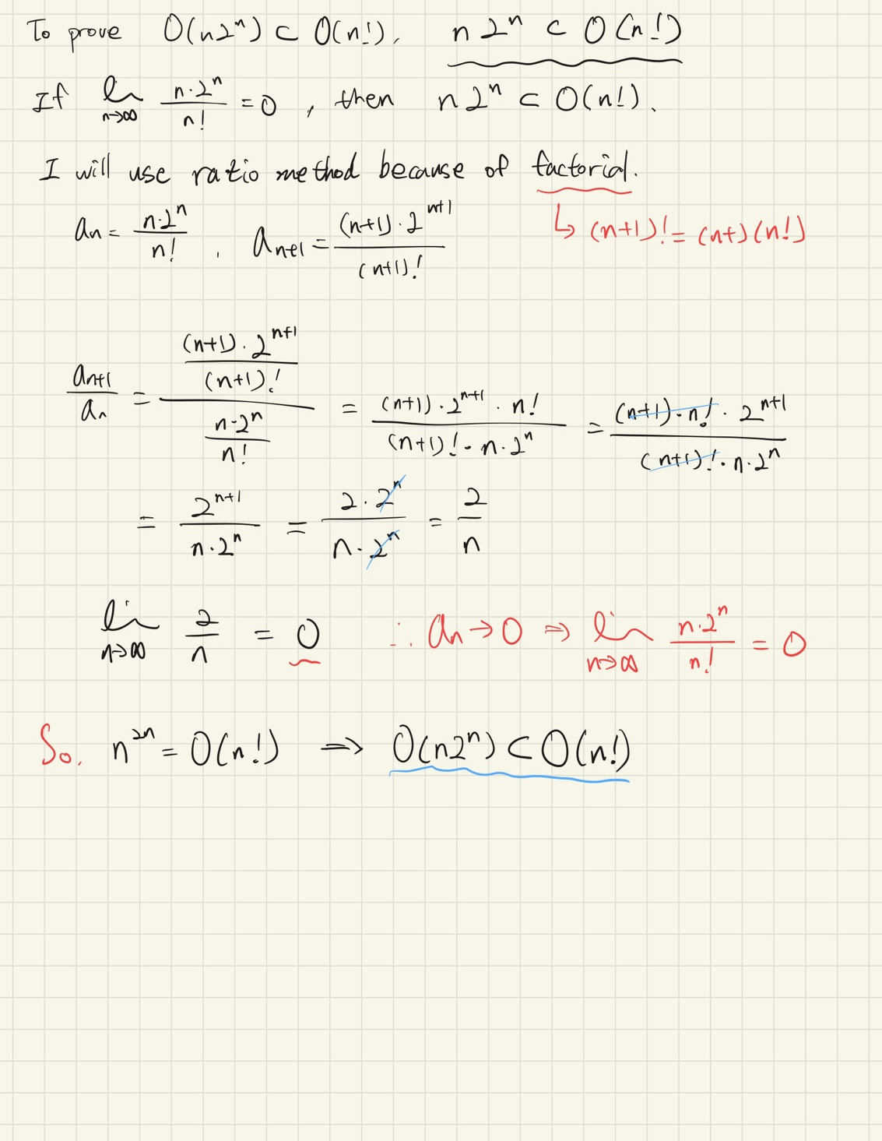
Transparency
    - I studied how to perform limit calculations when there is a factorial using AI.
    - https://chatgpt.com/share/69b6bba3-b948-8012-8a80-76974690905d

- (4 points) Run the following c++ code and get the result.
Screen capture your result and include your result image(s).
#include <iostream>
#include <sys/time.h>

int main() {
// get the current time (moment 1)
timeval tv;
gettimeofday(&tv, nullptr);
long start = tv.tv_sec * 1000000L + tv.tv_usec;

// a task that takes time
int cnt = 0;
for (int i = 0; i < 1000; i++) {
cnt++;
}
std::cout << "cnt: " << cnt << std::endl;

// get the current time (moment 2)
gettimeofday(&tv, nullptr);
long end = tv.tv_sec * 1000000L + tv.tv_usec;

// calculate the time difference between the two moments in microseconds
long difftime = (end - start);

// print the result
std::cout << "the time difference: " << difftime << " usec" << std::endl;

return 0;
}

cnt: 1000
The time difference: 261 usec
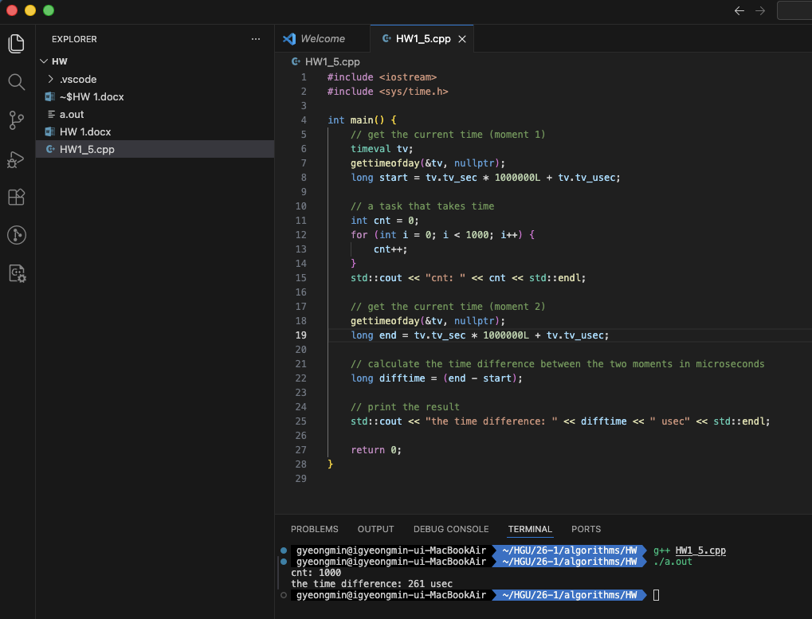

For Genius Track students
Write your reasons for challenging the bonus problem(s) and your thoughts here.

Transparency Track
Describe what you realized you did not fully understand through this assignment. here.

I did not know the exact meaning of average-case running time, nor did I fully understand why the highest growth term is sought when finding the simplest form. Through this assignment, I learned what L'Hôpital's rule is and when to use it, and I also learned how to calculate limits when factorials are involved.

Appendix
How to compile and run your c++ code:
- You may use any tool if you already have.
- Or go to Google Colab and write down the code in this way.
  - Write your code like below in the first cell but you must include
%%writefile program.cpp at the top of the code. Then, run the cell.
%%writefile program.cpp
#include <iostream>
#include <sys/time.h>

int main() {
// get the current time (moment 1)
timeval tv;
gettimeofday(&tv, nullptr);
long start = tv.tv_sec * 1000000L + tv.tv_usec;

// a task that takes time
int cnt = 0;
for (int i = 0; i < 1000; i++) {
cnt++;
}
std::cout << "cnt: " << cnt << std::endl;

// get the current time (moment 2)
gettimeofday(&tv, nullptr);
long end = tv.tv_sec * 1000000L + tv.tv_usec;

// calculate the time difference between the two moments in microseconds
long difftime = (end - start);

// print the result
std::cout << "the time difference: " << difftime << " usec" << std::endl;

return 0;
}
  - Write the following code in the second cell. Then, run the cell.
%%shell
g++ program.cpp -o execute
./execute

